Optional 49_ region_hh_ave_driver_per_capita
May 30, 2026
Definition of the Input File
There are two potential input files depending on which build is used
The VisionEval documentation mentions two files with two separate file names and two separate definitions; in both cases the file is optional. Experiments by the research team, using the multimodal module, on May 29, 2026 with a version downloaded in 2025 suggest that only the first file has an impact and thus that file is described here. However, a second file appears in the documentation and on other websites, and developers may have customized VisionEval to use this second file. The research team recommends that users either (1) decide not to use this optional file or (2) if they do use it, quickly ensure that changes in the file causes a change in outputs—that way, users do not lose time working with a file that does not affect results.
- The optional file region_hh_ave_driver_per_capita is defined in the documentation at https://github.com/visioneval/VisionEval/blob/main/sources/modules/VEHouseholdVehicles/inst/module_docs/AssignDrivers.md, which users can get to by going to https://visioneval.github.io/, choose download, choose the readme file at the very bottom of the page (which takes one to https://github.com/VisionEval/VisionEval-4), then click sources, then click modules, and then click the VEHouseholdVehicles, then inst, and then module_docs, and then choose Assign_Drivers.md. Although a 2018 date is shown, it appears that this file (region_hh_ave_driver_per_capita) is indeed what is used in the current module. This file is also referenced in Incorporating Automated Vehicles into Scenario Planning Models: Phase 2 (Tool Development and Pilot Testing) by ICF for FHWA. Changes to values in this file influenced the total of household DVMT as reported in Marea 2045 sample file examined by the research team.
- The optional file region_hh_driver_adjust_prop is mentioned in the documentation at https://visioneval.github.io/docs/model-inputs.html. This file also appears at https://visioneval.github.io/docs/validation-and-troubleshooting.html and in documentation for the Delaware Valley Regional Planning Commission (https://github.com/dvrpc/DVRPC-VisionEval-Inputs-Preparation/blob/main/documentation/Generating%20Input%20Tables/4.%20Household%20Vehicles/4.%20Household%20Vehicle.md_ and for the Fresno Council of Governments (https://www.fresnocog.org/wp-content/uploads/2026/04/SJV_VE_Documentation_Final.pdf). Changes to this input file did not influence the total of household DVMT. (This does not mean the file has no impact in work done for DVRPC or Fresno, as developers can customize VisionEval; it simply means that the research team, when using the standard VisionEval installation without any alterations except to use the multimodal module, did not detect any changes).
Definition of region_hh_ave_driver_per_capita
Based on the first URL mentioned in this documentation—the Assign Drivers Module, this is the ratio of “drivers to persons” in each of five age groups. For example, the data below suggest that 38.3% of persons age 15 to 19 have a driver’s license, both in 2024 and 2045. This percentage is considerably higher for the other age groups, with 89.4% of Virginians age 55 to 64 having a driver’s license in 2024 and 2045. These are the values shown in the CSV file in Table 1.
Table 1. Values Used for region_hh_ave_driver_per_capita
Definition of region_hh_driver_adjust_prop
Based on a later URL in this documentation, https://visioneval.github.io/docs/model-inputs.html, this file adjusts the “driver licensing rate” by age group relative to the model estimation year (which appears to be 2001). According to the documentation, the file contains five attributes, one for each age group, where a 1 indicates no adjustment.
For example, the data in Table 2 suggest that the ratio of drivers to the population age 15 to 19 in Virginia in 2024 will be higher than the same ratio for year 2001, with an adjustment factor of 1.11. By contrast, the table suggests that the ratio of drivers to population in the age 20 to 29 group in 2024, will be lower than the ratio for 2001 (with a factor of 0.63). If the ratio for licensed drivers to population were unchanged from 2001, then this file would have 1.0 in all cells. The methodology for deriving these values is given in the Appendix.
Table 2. Values for region_hh_driver_adjust_prop (detailed method described in the Appendix)
A more conservative set of changes (2001 to 2024) is shown in Table 3 and the methodology for deriving these values is given in the next section.
Table 3. Values for region_hh_driver_adjust_prop (simplified method)
Possible Scenario
Changes to this file would likely be useful for analyzing scenarios in which the model-estimated number of drivers is intentionally adjusted by age cohort to reflect observed or projected behavioral changes. For example, the file could be used to model scenarios involving declining driver licensing rates among younger populations or increasing driving participation among older populations. Such adjustments could influence model outputs related to DVMT, mode choice, household transportation costs, congestion, and emissions. The document Task 7.2 Simplified Scenario Development guide available at A Playbook for Simplified Approaches for Creating Scenarios in VisionEval does not mention this input file nor licensure.
Method Used for Virginia
Region_hh_ave_driver_per_capita
Table 6.3.3. Licensed drivers, by State, sex, and age group (shown as Table DL-22 in the FHWA 2024 Highway Statistics Series (https://www.fhwa.dot.gov/policyinformation/statistics/2024/) gives the number of licensed drivers for each age group in Virginia for year 2024, and the U.S. Census Bureau (table S0101, American Community Survey, one-year estimates for 2024) gives the population by age group. (This source gives Virginia’s total 2024 population as 8,811,195; the Weldon Cooper Center for Public Service gives a total (July 1) 2025 population as being 8,880,107 (https://www.coopercenter.org/virginia-population-estimates). In short, for each of the five age groups, the number of licensed drivers was divided by the population. For example, FHWA in Table DL-22 showed 224,520 licensed drivers in 2024 and the U.S. Census Bureau (in Table S0101 from the 2024 one-year ACS) showed a Virginia population of 585,661 persons in that age group, yielding a ratio of 0.383. The same values were presumed for 2024 and 2045.
Region_hh_driver_adjust_prop (simplified method)
The values shown in Table 3 were developed using a very simple approach: the ratio of all drivers to the population for the U.S. as a whole was 0.6701 in 2001, and this ratio was 0.70796 in 2024. The ratio of these two values (e.g., 2024 to 2001) was 1.056. These values are shown in Table 3.
Appendix: How to Derive Table 2
The corresponding Excel file shows how the values for Table 2 were derived. This is a more detailed method and one that should be studied by individual regions if implemented, but an advantage is that it considers rural and urban areas differently. The extrapolation method described below was developed by comparing driver licensing rates by age cohort between urban and rural areas and calculating the relative proportions of the West Piedmont PDC region, which was assumed to represent a rural area, relative to urban areas, which were assumed to have a baseline value of 1. Therefore, the values presented in this input file are likely most appropriate for rural regions such as WPPDC.

- Source: CSV V2.1, Survey Data, 2022 NHTS Datasets, National Household Travel Survey (NHTS)
  - URL: https://nhts.ornl.gov/downloads
  - Location: Not Applicable
  - Search Keyword: Not Applicable
  - Related Sheet: Not Applicable

- Year that the Data Reflect: 2022 (Since the 2022 dataset is the most recent available, its values were assumed to represent those for 2024.)

- How the Data Were Processed
  - Calculate the Number of Licensed Drivers by Rural or Urban Area: The fields R_AGE, DRIVER, and URBRUR were organized using a pivot table. Records with values of “2” and “-1” in the DRIVER field were excluded, as only “1” indicates a licensed driver. In the URBRUR field, values of “1” and “2” represent urban and rural areas respectively.
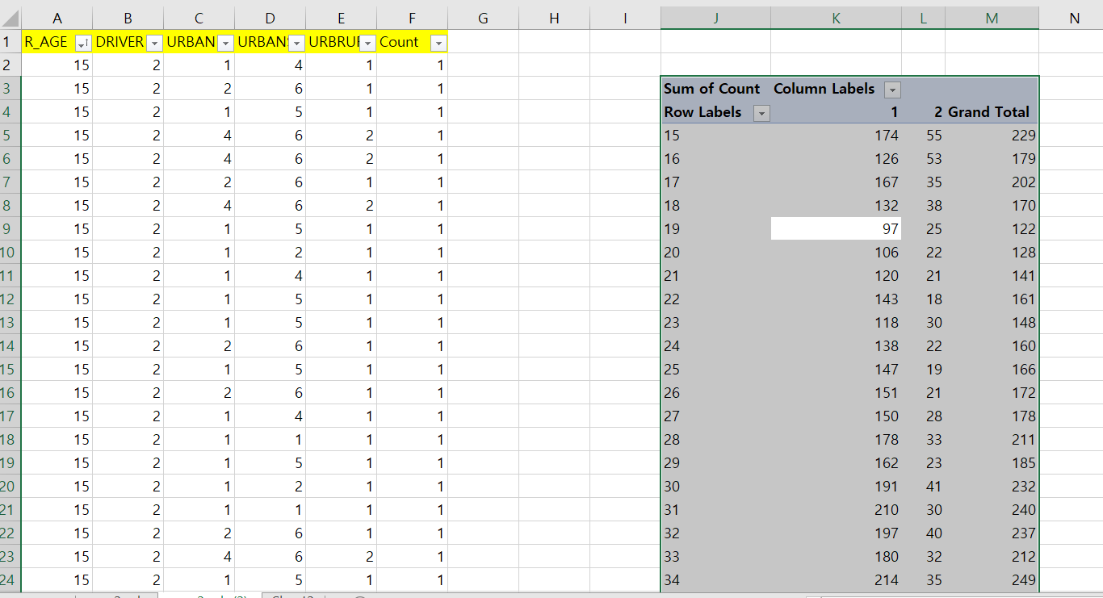

  - The values from region_hh_ave_driver_per_capita.csv were used to project the 2045 estimates. The 2045-to-2024 ratio was calculated and then applied to the 2024 values in region_hh_driver_adjust_prop.csv.
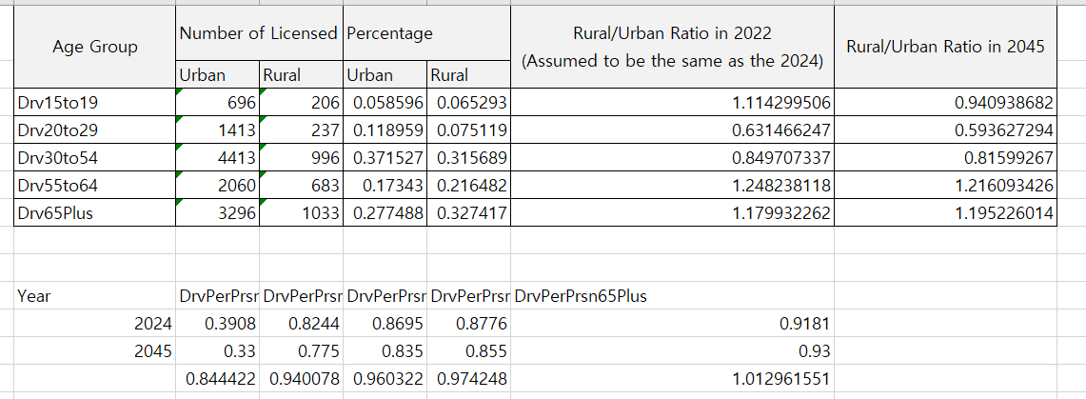
  - Final Result
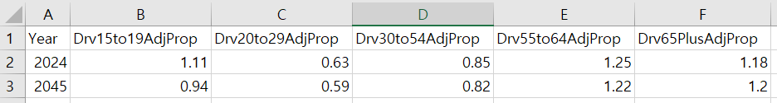

SCRAP Material
- Population by Selected Age Groups for the U.S. and all States: 2001
- Virginia Population Estimates | Cooper Center
- Table DL-20 - Highway Statistics 2023 - Policy | Federal Highway Administration
- https://visioneval.github.io/, https://github.com/VisionEval/VisionEval-4, sources, modules, VEHouseholdVehicles, /inst/, module_docs/
- VisionEval/sources/modules/VEHouseholdVehicles/inst/module_docs/AssignDrivers.md at main · VisionEval/VisionEval · GitHub
- Chapter 8 Validation and Troubleshooting | VisionEval User Guide
- DVRPC-VisionEval-Inputs-Preparation/documentation/Generating Input Tables/4. Household Vehicles/4. Household Vehicle.md at main · dvrpc/DVRPC-VisionEval-Inputs-Preparation · GitHub

